|  |
| --- |
| **From T’es Qui to Qui Es-Tu*:* A Naïve Bayesian Approach to Assessing Literate and Oral Discourse in Non-standard French Language Data**    Schriftliche Hausarbeit  für die Bachelorprüfung der Fakultät für Philologie  an der Ruhr-Universität Bochum  (Gemeinsame Prüfungsordnung für das Bachelor/Master-Studium  im Rahmen des 2-Fach-Modells an der RUB vom 03. November 2016)  Vorgelegt von  Chandler, Christopher  Abgabedatum  31.08.2021  Prof. Dr. Stefanie Dipper  Prof. Dr. Ralf Klabunde |

Table des matières

Abstract 3

List of Figures 4

List of Tables 4

Terminology 4

List of Abbreviations 4

1 Introduction 5

2 Related Works 6

2.1. Theoretical linguistics 6

2.2. Computational linguistics 7

3 General Features of Language and Discourse 8

3.1. Language: Parole, Langue and Communication 8

3.2. General Features of Orality as a Medium 10

3.1. General Features of Literacy as a Medium 10

3.2. Medium, Conception and Distance-Proximity 11

4 French Sociolinguistics 14

4.1. Le Français 15

4.1.1. Français Cultivé 16

4.1.2. Niveau Zero 16

4.1.3. Français Familier 16

4.1.4. Français Populaire 16

4.1.5. Français Vulgaire 16

4.2. Français Parlé: Typical Features of Orality in French 16

4.3. Français Écrit: Typical Features of Literacy in French 16

5 The French Language Corpora 17

5.1. Nature of the Data Sets 17

5.2. Data Pre-processing 17

6 Methodology 18

6.1. Discourse Classification with Naïve Bayes 18

6.2. Feature Sets for Identifying Discourse Types 18

6.3. Establishing Discourse Classification Baseline 18

7 Evaluation 18

7.1. Non-Statistical Evaluation Parameters 18

7.2. Statistical Evaluation Parameters 18

8 Discussion 18

8.1. Developmental Phase 18

8.2. Experimental and Training Phase 18

8.3. Testing Phase 18

9 Conclusion 18

References 19

Eigenständigkeitserklärung 21

# Abstract

# List of Figures

# List of Tables

# Terminology

# List of Abbreviations

français argotique FA

Français cultivé FCU

Français courant FCO

Français familier FF

Français Populaire FP

Français vulgaire FV

Niveau Zéro NZ

# Introduction

Excluding other modes in which human communication can be realized such as via sign language, body language, whistling, etc., human languages are generally expressed using at least one of the two discourse types: oral or literate discourse (Bader, 2002). In the most literal sense, oral discourse can be understood as process that employs audible sounds to express meaning, whereas literate discourse is visual medium that is expressed through visible, written symbols (Bader, 2002).

Furthermore, despite the somewhat trivial natural of this discourse classification, these two domains do not represent a natural dichotomy, as one might automatically assume, but rather, they are two sectors of language that regularly overlap.

Oral and literate discourse are often realized by employing non-standard language and standard language, respectively. In the strictest sense, standard language is language which conforms to norms set forth by an official linguistic institution or work e.g., Académie Française, Real Academia *Española*, Oxford English Dictionary, Duden, etc. This contrasts with non-standard language which is not beholden to any norms whatsoever. It is therefore often characterized by the heavy usage of dialectal and vernacular speech (Bader, 2002).

With respect to the aforementioned definitions, data that stems from scientific or professional sources such as newspapers, scientific journals, political speeches, etc. tends to exhibit a style that is more akin to literate discourse. This contrasts with SMS, chat messages, online ad postings, forum discourse, etc. as they generally exhibit a style that is more representative of oral discourse. (Bader, 2002).

It is however possible to discern to the two irrespective of the domain. However, the underlying problem in identifying an oral or a literate style within a text is twofold. First, there is the issue that written speech inherently lacks several paralinguistic cues that are associated with spoken speech like intonation, prosody, speed, accent, and so on (Bader, 2002). This is further compounded by the fact that written speech can also represent language that can realized be orally but is done so artificially. This paradigm applies to documents such as presentations, speeches, sermons and news reports.

One naïve solution to solving this problem would involve native speakers sentences by hand and classify according However, this approach is cumbersome and length. It would thus only be suitable if the corpus were reasonably small i.e., a couple dozen sentences at most. Therefore, the most efficient way in solving this dilemma would have to involve a method which allows for the automatic disambiguation of oral and literate discourse.

While this method can theoretically be applied to any language, the object language of this thesis is modern French from c. 2005 – 2019. The language data has been sourced from reputable sectors that are generally considered to be representative of standard as well as non-standard language. These includes Wiki-discussions, eBay postings, and SMS chats.

A common method of disambiguation that I will employ involves the supervised usage of a naïve bayes classifier with a specific feature and classification sets (Jurafsky & Martin, 2009). First, the feature sets which are to be typical of the respective discourse styles and how they can occur in a written medium must be identified. Then the naïve bayes will be trained according to these features thereby allowing the classifier to determine to a relative degree of probability if a given text is representative of oral or literate discourse. The methodology as well as the results of this process will be presented in detail at the end of this face.

# Related Works

When examining the concept of oral and literate language within the discipline of computational linguistics, it is paramount to include not only the theoretical aspect of the dynamic, but the computational one as well.

## Theoretical linguistics

Koch and Oesterreicher (1985) were very influential in setting up the paradigm of literate and oral discourse. They did this by providing a distinction between the medial and the conceptual facets of language. The medial aspect of the language refers to whether a given message is expressed in either a graphic or a phonetic medium. The conceptual aspect is then the either spoken or written. Koch and Oesterreicher (2007) reprised their roles in offering a more detailed explanation regarding literate and oral discourse. They also place focus on sociolinguistic aspects regarding this paradigm.

Another factor that plays a role in identifying orality and literacy in a text is that of *Distanzsprache* and *Nähesprache[1]*. Distanzsprache represents how removed the speaker is mentally, conceptually and physically. On the other hand, Nähesprache depicts how close one is to any given situation. Situations that are more of a personal and physical nature will often be assigned to the category of Nähesprache.

As the specific object language in question is French, there are French-specific elements that should be taken into and will be instrumental in determining the necessary features. While Müller (1975) predates Koch and Oesterreicher (1985), the notion of orality and literacy was already known to Müller (1975) and refers to them as *français parlé, message oral, languée* and *français écrit, message écrit, langue écrite, langage écrit* respectively. Alongside other aspects, Müller (1975) explores this distinction and how it is realized chronologically, quantitatively, qualitatively, diatopically, diastratically with special focus placed on the French language.

## Computational linguistics

Using a naïve bayes classifier for text classification purposes is on itself not a new process. However, what is new and has been seldom done is using it to identify oral and literate nature of a give text. Ortmann and Dipper (2019) asses the ideas as proposed by Koch and Oesterreicher(1985) to be able to automatically identify literate and oral discourse in modern German texts.

Ortmann and Dipper (2020) also applied the same methodology, also referencing Koch and Oesterreicher (1985), to assess the oral and literate nature of historical texts. This was done by using a slightly altered feature set that is more adept to historical texts as the non-standardized nature of historical documents cannot be properly analyzed using modern criteria.

To better identify literacy and orality in a text Ortmann and Dipper (2019), drew from Bader (2002) and Rehm (2001) who both provide such criteria, albeit from slightly different angels. Bader (2002) provides a rounded, general approach to properly assess orality and literacy in texts in the same vein as Müller (1975). Bader (2002) applies the analyses to digital communication e.g. e-mail, chat, newsgroups, etc., while also providing features to identify the precise nature of individual excerpts from said communication. Rehm (2001) offers a more restricted analysis by only detailing the nature, characteristics and features of written language on the internet e.g. e-mail, chat data, websites, etc.

The internet is an everchanging dimension and one could therefore rightfully question the validity of using such articles from nearly two decades ago. However, despite both articles having been published at the turn of the 21st century, where the internet and digital communication were still in their infancy, both works comment and detail phenomena that are still relevant to modern internet communication.

# General Features of Language and Discourse

## Language: Parole, Langue and Communication

As a mode of communication, it is something that humans have been capable of for around 100,000 years (Stein, 2014). Human Language, is first and foremost, the production of audible sounds i.e., speech or written symbols i.e., letters, characters, etc. (Bader, 2002).

It is tempting to analyze and define language by contrasting it with the concept of dialects. While this can be done, the goal here is to provide a general definition of what exactly is meant by language as a construct. Furthermore, to preserve the dichotomy of written versus spoken, language here will be treated as being confined to these two dimensions.

De Saussure makes the distinction of *Parole* versus *Langue*. Parole being the actual realization of language system. Langue being the virtual construct of a given language that could be realized by a speaker of said language (Stein, 2014).

The language system is simply the aggregation of conventions, norms, value and opposition. The value of a given word, be it phonetic or graphic, is that it can be distinguished from another element. If there is a distinction between these two elements, then opposition is present (Stein, 2014). Should they have the same function, then it would be necessary to refer to them as variants of one another.

A final important aspect of language is the relationship that speakers have to one another. More specifically, how communication can work between speakers. There exist at least two main models Jakob and Bühler for explaining the communication aspect of language, but they serve the same purpose, which is to present the function of language (Stein, 2014) .

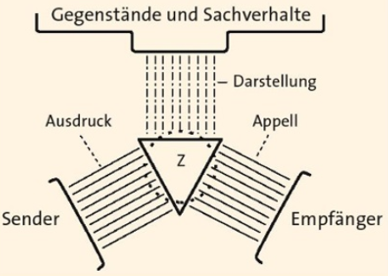

Bühler Organ-Modell (Stein, 2014, p. 1)

The organ model is a communication model that models the way linguistic information is received and processed. Every communication process consists of three essential parts: *Sender*, *Empfänger* and Gegenstände und Sachverhalte. *Sender* is the speaker, with *Empfänger* being the listener. Gegenstände und Sachverhalte are the messages being transmitted. All three of these are connected through Z which represents the language i.e., *das sprachliches Zeichen* (Stein, 2014).

The sprachliches Zeichen is simply what every is transmitted via language. It has three main functions: Ausdruck, Darstellung, Appel. The Ausdruck expresses the opinions and feelings of the speaker. These are the symptoms of the sprachliches Zeichen. (Stein, 2014). The Darstellung is the symbol for the information. The Appel has the function of eliciting a desired response from the listener that is in line with the the sprachliches Zeichen. (Stein, 2014). All three of these functions are present in every message, but general one message will dominate over the others (Bader, 2002).

On a closing note, one of the most prominent features of human language, is that it is possible to transmit abstract information in a phonetic or graphical form (Stein, 2014). This is an ability that connects all humans, while at the same distancing them from other animals (Bader, 2002).

## General Features of Orality as a Medium

Oral speech in the most simplest can be understood as the phonetic expression of thought (Bader, 2002). This is in line with De Saussure, who along with other structural linguists, saw spoken language superseding and therefore being the precursor of written language (Stein, 2014). Due to the nature of orality being a primary factor chronologically speaking (Bader, 2002; Koch and Oesterreicher 1985), it is the feature that is the most prominent and the one that has been object of great discussion, especially since the 20th century (Stein, 2014)

Furthermore, speaking is a spontaneous process that is directly coupled with the transience (Bader, 2002). This real-time process prevents spoken language from becoming overly complex as it would overload the listener’s ability to ascertain the meaning from the message (Ortmann & Dipper, 2019). The working memory of the speaker is also the reason as to why the information density in spoken speech is relatively low.

The fact that speech is spontaneous and directly dependent on a speaker’s ability to be able to process the linguistic information in real time has a direct impact on syntax. That is to say that the active voice and elliptical structures are preferable in spoken speech as they are most likely easier to process (Ortmann & Dipper, 2019). This is evident in the lexical aspect too as “spoken language is characterized by frequent use of various particles, e.g., answer and modal particles in German (…) and interjections” (Ortmann & Dipper, 2019, p. 4).

## General Features of Literacy as a Medium

Seeing as how orality is the phonetic expression of thought, literacy is then to be seen as graphical depiction and recording of said thought (Bader, 2002). The basic reason as to why written speech exists at all can be summed up as it being essential to transport thoughts, messages, etc. over long distances and to preserve them for future generations. It was and is a way to escape the transience paradigm of spoken language (Ortmann & Dipper, 2019).

Written language has often been seen viewed as the true paradigm of language. In that, if language is mentioned, then it must automatically refer to the written variant. This was the prevailing assumption well into the 19th century (Koch & Oesterreicher, 1985). This is the reason why written language has often been the necessary default mode when examining an object language.

Written language is often in contrast with spoken due the dichotomous nature of the language paradigm. Where spoken language is restricted to being less complex, written language can benefit from static properties of a textual medium. (Ortmann & Dipper, 2019). This naturally carries over into the syntactical and lexical structure of any given written message. Syntactical and lexical properties can be expounded upon in a general without having to take the speaker’s ability into consideration.

An important property is that “Written language can express features of orality with specific graphical means, such as omission of characters, word contractions, or use of ellipsis dots, em dashes or apostrophes”(Ortmann & Dipper, 2019, p. 67). This feature can be exploited to identify markers that are proto-typical of spoken language((Ortmann & Dipper, 2019); (Ortmann & Dipper, 2020) (Bader, 2002)) The possibility to emulate spoken speech through text a medium cross over into the realm of the medial and conceptual distinction of language, which will be touched in more detail in the following section.

## Medium, Conception and Distance-Proximity

Koch and Oesterreicher (1985) have created an elegant, but simple paradigm of addressing the conceptual and medial nature of discourse types.

|  |  |  |  |
| --- | --- | --- | --- |
|  | Konzeption | | |
| Medium |  | Gesprochen | Geschrieben |
| Graphischer  Kode | Faut pas le dire | Il ne faut pas le dire |
| Phonischer  Kode | [fopaldiʀ] | [ilnəfplalədiʀ] |

Fig. 1 (Koch & Oesterreicher, 1985, p. 17)

Although it would be wrong to see a dichotomy being present between orality and literacy, this is not strictly correct. The dichotomy does exist, but it only applies to the dual nature of the discourse. Excluding all other modes, either a message is communicated through spoken speech, or it written speech. Regarding the medial representation, i.e., the graphic code and the phonetic code , a dichotomy is present. The other question remains though: What is to be done with the conceptual aspect of language?

Here, it would be false to assume that spoken speech can only represent spoken speech and written speech can only represents speech. Koch and Oesterreicher(1985) see ,spoken’ and ,written’ as being a continuum with conceptual possibilities that have different levels. They exemplify this in the following diagram.

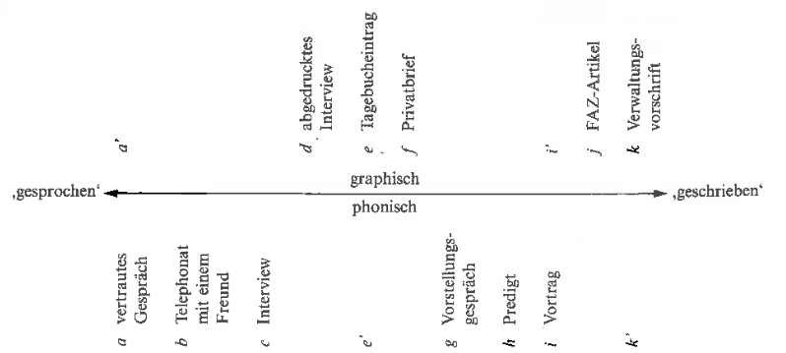

Fig. 2 (Koch & Oesterreicher, 1985, p. 17)

On the phonic portion of the diagram, a,b,c,g,h,i represent spoken speech that starts of being of a informal and personal nature and gradually becomes less informal and person. In doing so, it is more in lines with written speech. When observing the two poles, a and i, there is an obvious difference between an informal conversation and a presentation. The former most likely represents spontaneous speech, while the latter is something that prefabricated and then presented to an audience in an oral form. On the graphic portion of the diagram, d,e,f,j,k all represents possible graphic representations of speech, with a prepared interview being the most oral and an administrative regulation being the most written and least spoken realization.

Another dynamic presented by Koch and Oesterreicher(1985) is that of *Nähe* and *Distanz*. It is not enough to simply address the written or spoken nature of any given speech, but also address how close in terms of proximity and familiarity the speakers are to one another. Nähesprache is reserved for situations that physical and familiar in nature. This includes, but is not limited to, communication that is spontaneous, face-to-face and familiar. Distanzsprache represents the opposite pole in that it depicts speech that includes, but is not limited, communication that is detached, objective, unfamiliar.

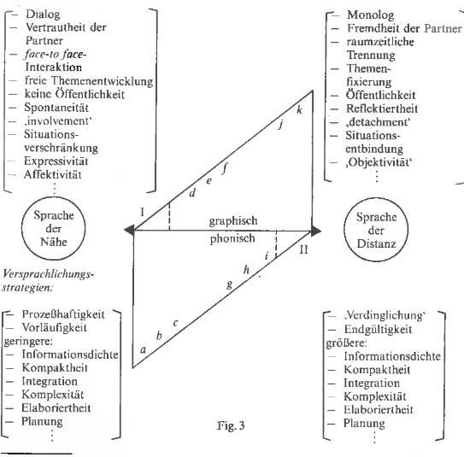

Fig. 3 (Koch & Oesterreicher, 1985, p. 17)

Using all, three of these parameters: Medium, Conception and Distance-Proximity, a more detail analysis of language is possible. An informal conversation is thus representative of spoken speech, that is also conceptual representative of spoken speech. The dynamic of the speakers is one familiarity and closeness, and the speech can therefore be assigned the label of Distanzsprache. The opposite can be said of administrative regulation. There is great distance between the speakers, both in terms of familiarity and proximity. It is also not a message that can be communicated orally due to the very nature of the text. Therefore, it can be assigned as being conceptually and medially written speech, while also belonging to Distanzsprache.

# French Sociolinguistics

Sociolinguistics is the scientific study of the relationship between language and society. It deals with the linguistic phenomena that occur within society (Bieswanger & Becker, 2008; Stein, 2014). By employing sociolinguistics, it is possible to investigate the effects of extra linguistic factors on society. Furthermore, a speaker’s linguistic choices often give information about their social and geographical background (Bieswanger & Becker, 2008).

Registers are such linguistic phenomena that are general points of interest for linguistics involved in sociolinguists(Bieswanger & Becker, 2008). Registers, or styles, can be loosely defined as:

the function of language in a particular situation and the consideration of such factors as addressee, topic, location and the interactional goal rather than background of the speaker. The exact definition of style and register is difficult (…). A common distinction is that style refers to the level of formality of an utterance or a text, whereas register refers to the choice of vocabulary in an utterance or a text. (Bieswanger & Becker, 2008, p. 187)

Alongside style and register exist a host of other phenomena that are accounted for in sociolinguistics, such as: qualitive registers, quantitative registers, sociolects, diatopic view, diastratic view, gender, age, norms, etc. (Achim, 2014; Bieswanger & Becker, 2008; Müller, 1975).

All these elements can eb instrumental in determining oral and literacy provided that there are textual identifiers for them. The reasoning behind touching on French sociolinguistics is that certain sociolinguistic phenomena are directly tried to medium (oral/literate), concept (written/spoken) and nähe-distance. That is to say that certain registers, styles, etc. are usually only realized in a specific given situation. Therefore, if medium and concept do not align, it can be better identified in text. The subsequent chapters deal with the sociolinguistic aspects and how they can be identified in text and thus implemented in computational linguistic program.

## Le Français

Historically speaking, French was as having a single register. This is not in the sense that it there was no variation, but rather, that there was one and only one correct way of using the French language, often referred to as *Bon usage* (Müller, 1975). *Mauvais usage* and *Dites …ne dites pas* dictated the correct the usage of French for the majority of French history.

This was in part due to the academic body, Académie Française, who was, and still is, instrumental in setting norms for French (Müller, 1975). Nevertheless, it is not necessarily feasible to entirely dictate what speakers of any given language do or say as this is directly antithetically to a defining character of language construct, which says that languages are in a constant state of change (Müller, 1975; Stein 2008).

The world wars, the decolonization of Africa and Asian coupled with French being supplanted by English as the dominant lingua France accelerated a process that was already in motion. They led to a rapid change in what was considered as proper and non-proper French. into other registers.

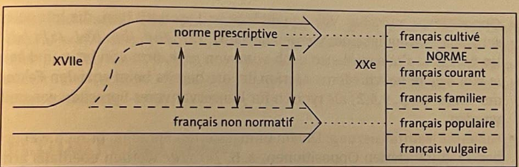

(Stein, 2014, p. 185)

The adherence to these norms and the dissolving of thereof has led to a very rich tapestry of registers and styles that are vastly different from the standard language, while at the same time being internally consistent. Their usage is also consistent with respect to time and location.

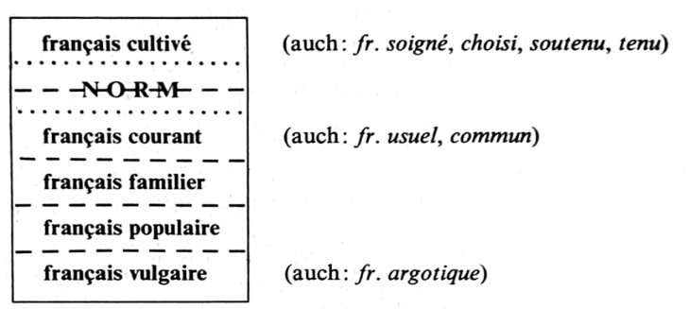

(Müller, 1975, p. 184)

At the most fundamental level, French registers are usually classified as *français cultivé, niveau zéro, français courant, français familier, français Populaire, français vulgaire*. *français cultivé* being the mostformal and français vulgaire being the least formal (Müller, 1975; Stein 2014). As evident in the diagram, many of these registers have different referents, but denote the same speech patterns. For the sake of simplicity, the French registers will only be referred to terms previously mentioned.

### Français Cultivé

FC is often referred to as français soigné, français choisi, langue recherché, langue tenue, langage soutentue, style noble (Müller, 1975). This register often viewed in positive light and seen as the register that one should try to replicate. Seeing as how this register considered the highest register. It is should not be used in banal or informal situation otherwise the speaker risks be seen as being pedantic and pretentious (Müller, 1975). It is used in official situations, special ceremonies or other special occasions. This register can occur in langage parlé as well was langage écrit.

The most prominent feature of FC in speech is the phonological component. It tends to consequently conserve sounds that are no longer used in the other registers. This includes but is not limited to phonetic opposition of certain sounds, the pronunciation of the schwa at the end of phonological words and more rigid syllable structure. This has to due with the desire to retain the literary tradition, which is often dependent on such archaisms (Müller, 1975).

FC as langage écrit retains certain grammatical features that have not been used in other contemporary registers for quite some time. Certain verb tenses such passé simple, passé antérieur, subjonctif imparfait or inversion. Other atypical structures present within FC are archaisms, scientific vocabulary, literary vocabulary and the strict adherence to proper negation e.g., ne…pas, ne..point, ne guère and archaic conjunctions. (Müller, 1975). Whether spoken or written, the most important element of FC is that is a register that is artificial in the sense that is a controlled process that is heavily reliant on proper word choice, intonation. This triggers a final feature of FC as sentences in this register tend to be fairly long (Müller, 1975).

### Français Familier

FF is a qualitative register that is quite close to FC. It is often used in informal situations such as with family, job, daily routine, acquaintances and people from one’s inner social circle (Müller, 1975). The register is often consigned to français parlé and signalizes a nonchalant attitude and familiar atmosphere. It is a register that is indifferent to the social standing of the speaker. Nevertheless, it is, however, a register that is more in use by those have profited from a higher education than those who have not (Müller, 1975). It is a register that is spontaneous in nature, and this is reflected in the fact that that there is not a lot of emphasis placed on proper enunciation. This allows for a direct comparison between FC and FF (Müller, 1975).

In FF, statements and questions are formed through falling and rising intonation, respectively. A less used approach is the formation of the question using *est-ce que*. This can be viewed as a half-step between FF and FA, as this *est-ce que* is more representative of the higher spectrum of the register (Müller, 1975).

The doubling of pronouns or referents e.g. moi je, ton père il is characteristic of FF. This can also be seen in topicalization e.g. **Cet homme**, je **l'**ai vu très souvent. This construction is a left-over of bon usage and free syntax rules (Müller, 1975).

### Français Populaire

FP

### Français Vulgaire

FV is lowest register both in terms of prestige and formality. It is therefore often referred to as *vulgaire, bas, grossier, trivial, obscene* (Müller, 1975). It is often grouped together with FA. The difference being that FV and its components are generally known to all speakers of French, where as FA is restricted to certain milieus. Interjections, expressions of displeasure, Expletives are present throughout FV.

FA is therefore avoided whenever possible as it is in direct opposition to social norms regarding etiquette due to how it can be used to described things in an indecent manner. It is notable for its lack of scientific jargon, latin loanwords, euphemisms. It is also incredibly adept at coining new words that employ the method of directness.

## Français Parlé: Typical Features of Orality in French

## Français Écrit: Typical Features of Literacy in French

# The French Language Corpora

French, as with any natural human language, is not a monolith, but a language that is spoken across, many domains, age groups, countries, etc. (Stein, 2014; Müller 1975). Whether a native speaker of metropolitan French, second-language speaker or speaker of given French dialect, this variation is present in France and outside as well (Stein, 2014). This poses a challenge of sorts since what is of the literal or oral discourse is to some extent dependent on the local and personal understanding of the language. Due to this, some concessions and compromises must be made in order for the subsequent chapters to be sound.

First and foremost, the object language here in question is that of Metropolitan French. The methods and reasoning will therefore apply to this variant of French. While it might very well be possible that the methods and reasoning are applicable to other varieties such as Swiss French, Belgian French, Canadian French, etc., that is not necessarily goal, but might be an eventual byproduct.

Secondly, the data records stem from ca. 2000-2020 and can therefore only accurately encapsulate and illustrate the language at this stage. Of course, the age of each speaker would allow for an analysis that could potentially stretch further back into the past. However, no assumptions can or will be made about the language state before 2000 or projects about the language beyond 2020 as this would be purely conjecture.

Lastly, even though Metropolitan French is the object language, there is no feasible way to know if a speaker is completely in line with this standard. Seeing as how the internet is an open platform, and therefore not bound to geographical constraints, it is plausible that speakers of other varieties have partaken in the conversations.

## Nature of the Data Sets

## Data Pre-processing

# Methodology

## Discourse Classification with Naïve Bayes

## Feature Sets for Identifying Discourse Types

## Establishing Discourse Classification Baseline

# Evaluation

## Non-Statistical Evaluation Parameters

## Statistical Evaluation Parameters

# Discussion

## Developmental Phase

## Experimental and Training Phase

## Testing Phase

# Conclusion

# References

Bader, J. (2002). Schriftlichkeit und Mündlichkeit in der Chat-Kommunikation. *Network*, *29*. <https://doi.org/10.15488/2920>

Barme, S. (2012). *Gesprochenes Französisch*. De Gruyter. <https://doi.org/10.1515/9783110279832>

Bieswanger, M., & Becker, A. (2008). *Introduction to English Linguistics* (2nd ed.). Narr Franke Attempto Verlag.

Cook, J. (2012). Les marques lexicales du français familier dans la traduction polonaise des dialogues romanesques. *Traduire*, *226*, 93–107. <https://doi.org/10.4000/traduire.162>

Gerstenberg, A., & Hewett, F. (2019). *A collection of online auction listings from 2005 to 2018 (anonymised)* [Data set]. La-bank: Resources for Research and Teaching. <https://www.uni-potsdam.de/langage/la-bank/ebay.php>

Goudailler, J.-P. (2002). De l’argot traditionnel au français contemporain des cités. *La linguistique*, *38*(1), 5–24. Cairn.info. <https://doi.org/10.3917/ling.381.0005>

Jurafsky, D., & Martin, J. H. (2009). *Speech and language processing: An introduction to natural language processing,computational linguistics, and speech recognition* (2nd ed.). Prentice-Hall, Inc.

Koch, P., & Oesterreicher, W. (1985). Sprache der Nähe—Sprache der Distanz: Mündlichkeit und Schriftlichkeit im Spannungsfeld von Sprachtheorie und Sprachgeschichte. *Romanistisches Jahrbuch*, *36*, 15–43.

Koch, P., & Oesterreicher, W. (2007). Schriftlichkeit und kommunikative Distanz. *Zeitschrift Für Germanistische Linguistik*, *35*, 246–275.

Müller, B. (1975). *Das Französische der Gegenwart: Varietäten, Strukturen, Tendenzen*. Winter.

Ng, H. T. (1997). Exemplar-Based Word Sense Disambiguation” Some Recent Improvements. *Second Conference on Empirical Methods in Natural Language Processing*, 208–2013. <https://www.aclweb.org/anthology/W97-0323>

Ortmann, K., & Dipper, S. (2019). Variation between different discourse types: Literate vs. oral. *Proceedings of the sixth workshop on NLP for similar languages, varieties and dialects*, 64–79. <https://doi.org/10.18653/v1/W19-1407>

Ortmann, K., & Dipper, S. (2020). Automatic orality identification in historical texts. *Proceedings of the 12th language resources and evaluation conference*, 1293–1302. <https://www.aclweb.org/anthology/2020.lrec-1.162>

Panckhurst, R. (2016). A digital corpus resource of authentic anonymized French text messages: 88milSMS—What about transcoding and linguistic annotation? *Digital Scholarship in the Humanities*, *21*, 92–102. <https://doi.org/10.1093/llc/fqw049>

Panckhurst, R., Détrie, C., Lopez, C., Moïse, C., Roche, M., & Verine, B. (2016). *88milSMS. A corpus of authentic text messages in French (nouvelle version du corpus ISLRN : 024-713-187-947-8)* (Cmr-88milsms-tei-v1) [Data set]. Banque de Corpus CoMeRe. <https://hdl.handle.net/11403/comere/cmr-88milsms/cmr-88milsms-tei-v1>

Poudat, C., Grabar, N., Kun, J., & Paloque-Berges, C. (2015). *TEI-CMC version of wikipedia discussions associated to the article “Quotient intellectuel”* (Cmr-wikiconflits-qi_discu-tei-v1) [Data set]. CoMeRe Corpora Repository. <https://hdl.handle.net/11403/comere/cmr-wikiconflits/cmr-wikiconflits-qi_discu-tei-v1>

Prüßmann-Zempher, H. (2010). 337. Varietätenlinguistik des Französischen / Linguistique des variétés. In G. Holtus, M. Metzeltin, & C. Schmitt (Eds.), *Band V/1 Französisch* (pp. 830–843). Max Niemeyer Verlag. <https://doi.org/10.1515/9783110966091.830>

Rehm, G. (2002). Schriftliche Mündlichkeit in der Sprache des World Wide Web. In A. Ziegler & C. Dürscheid (Eds.), *Kommunikationsform E-Mail* (pp. 263–308). Tübingen. <http://www.georg-re.hm/pdf/Rehm-Muendlichkeit.pdf>

Stein, A. (2014). *Einführung in Die Französische Sprachwissenschaft* (4th ed.). J.B. Metzler.

# Eigenständigkeitserklärung

I hereby declare that the work submitted is my own and that all passages and ideas that are not mine have been fully and properly acknowledged. I am aware that I will fail the entire course should I include passages and ideas from other sources and present them as if they were my own.

Hiermit versichere ich, dass ich die Arbeit selbständig angefertigt, außer den im Quellen- und Literaturverzeichnis sowie in den Anmerkungen genannten Hilfsmitteln keine weiteren benutzt und alle Stellen der Arbeit, die anderen Werken dem Wortlaut oder dem Sinn nach entnommen sind, unter Angabe der Quellen als Entlehnung kenntlich gemacht habe.

|  |  |
| --- | --- |
| Ort/Place, Date/Datum | Name |
| Kamen, 14.08.2021 |  |
|  | Christopher Michael Chandler |

1. These are also sometimes referred to as Sprache der Distanz and Sprache der Nähe respectively without any change meaning.